\ | 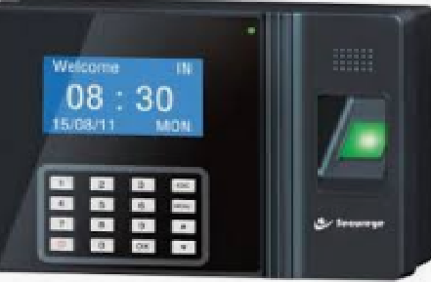  BIO METRICS / BIO MEDICAL BASED PROJECT TITLES
sl no | TITTLE
STAE001 | FINGER PRINT PREDICTION ENABLED PASSPORT AUTHENTICATION SYSTEM
STAE002 | INVOLUNTARY,BIOMETRIC DOOR ACCESS CONTROL AND ATTENDANCE MAINTENANCE SYSTEM
STAE003 | HIGH PROTECTION SECURITY SYSTEM WITH BIOMETRIC AND VIDEO TRANSMISSION
STAE004 | BIO METRIC RECOGNITION SYSTEM BASED DIGITAL VOTING MACHINE
STAE005 | ELECTRONIC LIBRARY MANAGEMENT SYSTEM USING FINGER PRINT SENSOR
STAE006 | PATIENT MEDICAL INFORMATION SYSTEM USING FINGER PRINT
STAE007 | FINGER PRINT PREDICTION ENABLED PASSPORT AUTHENTICATION SYSTEM
STAE008 | INVOLUNTARY,BIOMETRIC DOOR ACCESS CONTROL AND ATTENDANCE MAINTENANCE SYSTEM
STAE009 | IVRS BASED AUTOMATIC TELLER MACHINE TRANSACTION SYSTEM WITH THE HELP OF RFID TECHNOLOGY FOR BLIND PEOPLE WITH BIOMETRIC AUTHENTICATION
STAE010 | HIGH PROTECTION ATM SYSTEM WITH FINGER PRINT IDENTIFICATION TECHNOLOGY WITH IMAGE RECORD AND GSM
STAE011 | MEMS BASED PC COMMANDS USING HAND SIGNALS

